# **GenAI Orchestrator for Email and Document triage/routing**

**Overview of Challenge:**

Commercial Bank Lending Service teams receive a significant volume of servicing requests through emails. These emails contain diverse requests, often with attachments and will be ingested to the loan servicing platform and creates service requests which will go through the workflow processing. Incoming service requests (SR) via e-mail require a manual triage, where a "Gatekeeper" who:

Reads and interprets the emails content and attachments.

Identify the intent of the email and classify the "Request Type" and "Sub Request Type".

Extract key attributes for populating in service requests.

Assigns the request to the appropriate team or individual based on roles and skills.

This manual triage process requires a team of gate keeps and time consuming. Sometimes its inefficient and error prone when volume is large.

The challenge is to automate email classification and data extraction using Generative Al (LLMs), improving efficiency, accuracy and turnaround time. Also, minimizing gate keeping activities. Participants will leverage freely available tools to develop a solution that can classify the emails and extract relevant information to populate in service requests. Later this will be used autoroute the service requests to the correct processors (Team who works on the requests based on the request type) based on skill-based routing.

## Approach:

1. Config.json file is input configuration where we have defined Request types, sub-request types and terms to be extracted
2. Extracted content from different file types .eml and .msg extensions
3. Also, considered attachments of types pdf, doc, and img
4. Prompt that we are inputting is dynamically being constructed based on the input configuration
5. Considered TogetherAI platform to leverage llama-3-2-11b-free model
6. output is labelled data elements in Json format for easy consumption by servicing tool.
7. Can be invoked via API for B2B integration.

Technology Stack:  
Python, Together AI API client (llama-3-2-11b-free), Flask API, pytesseract for OCR, Postman for endpoint testing.

## How to run:

1. Use requirement.txt to install all necessary packages.
2. Signup into together ai and generate a token (https://api.together.xyz/settings/api-keys)
3. Save the token in system environment variable (TOGETHER_API_KEY) and save it.
4. Run Python Email_Orchestrator_TogetherAI.py

## Flow Diagram:

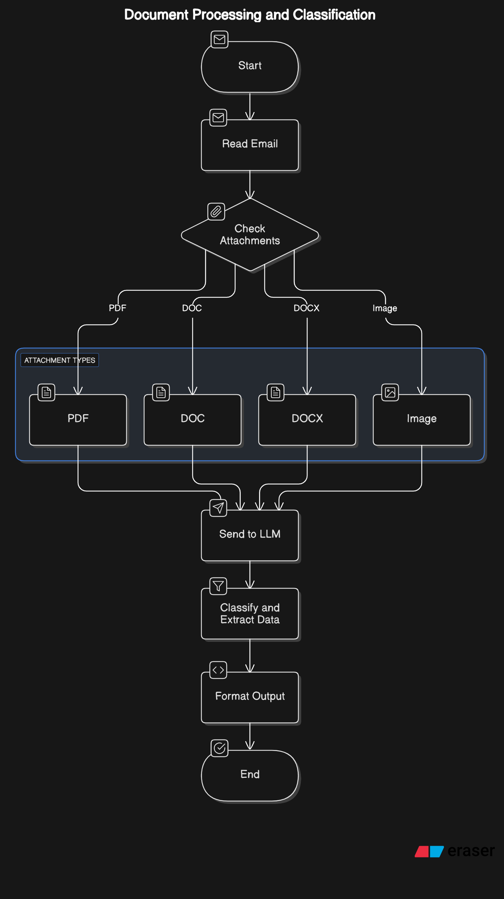

Output in JSON :  
  
